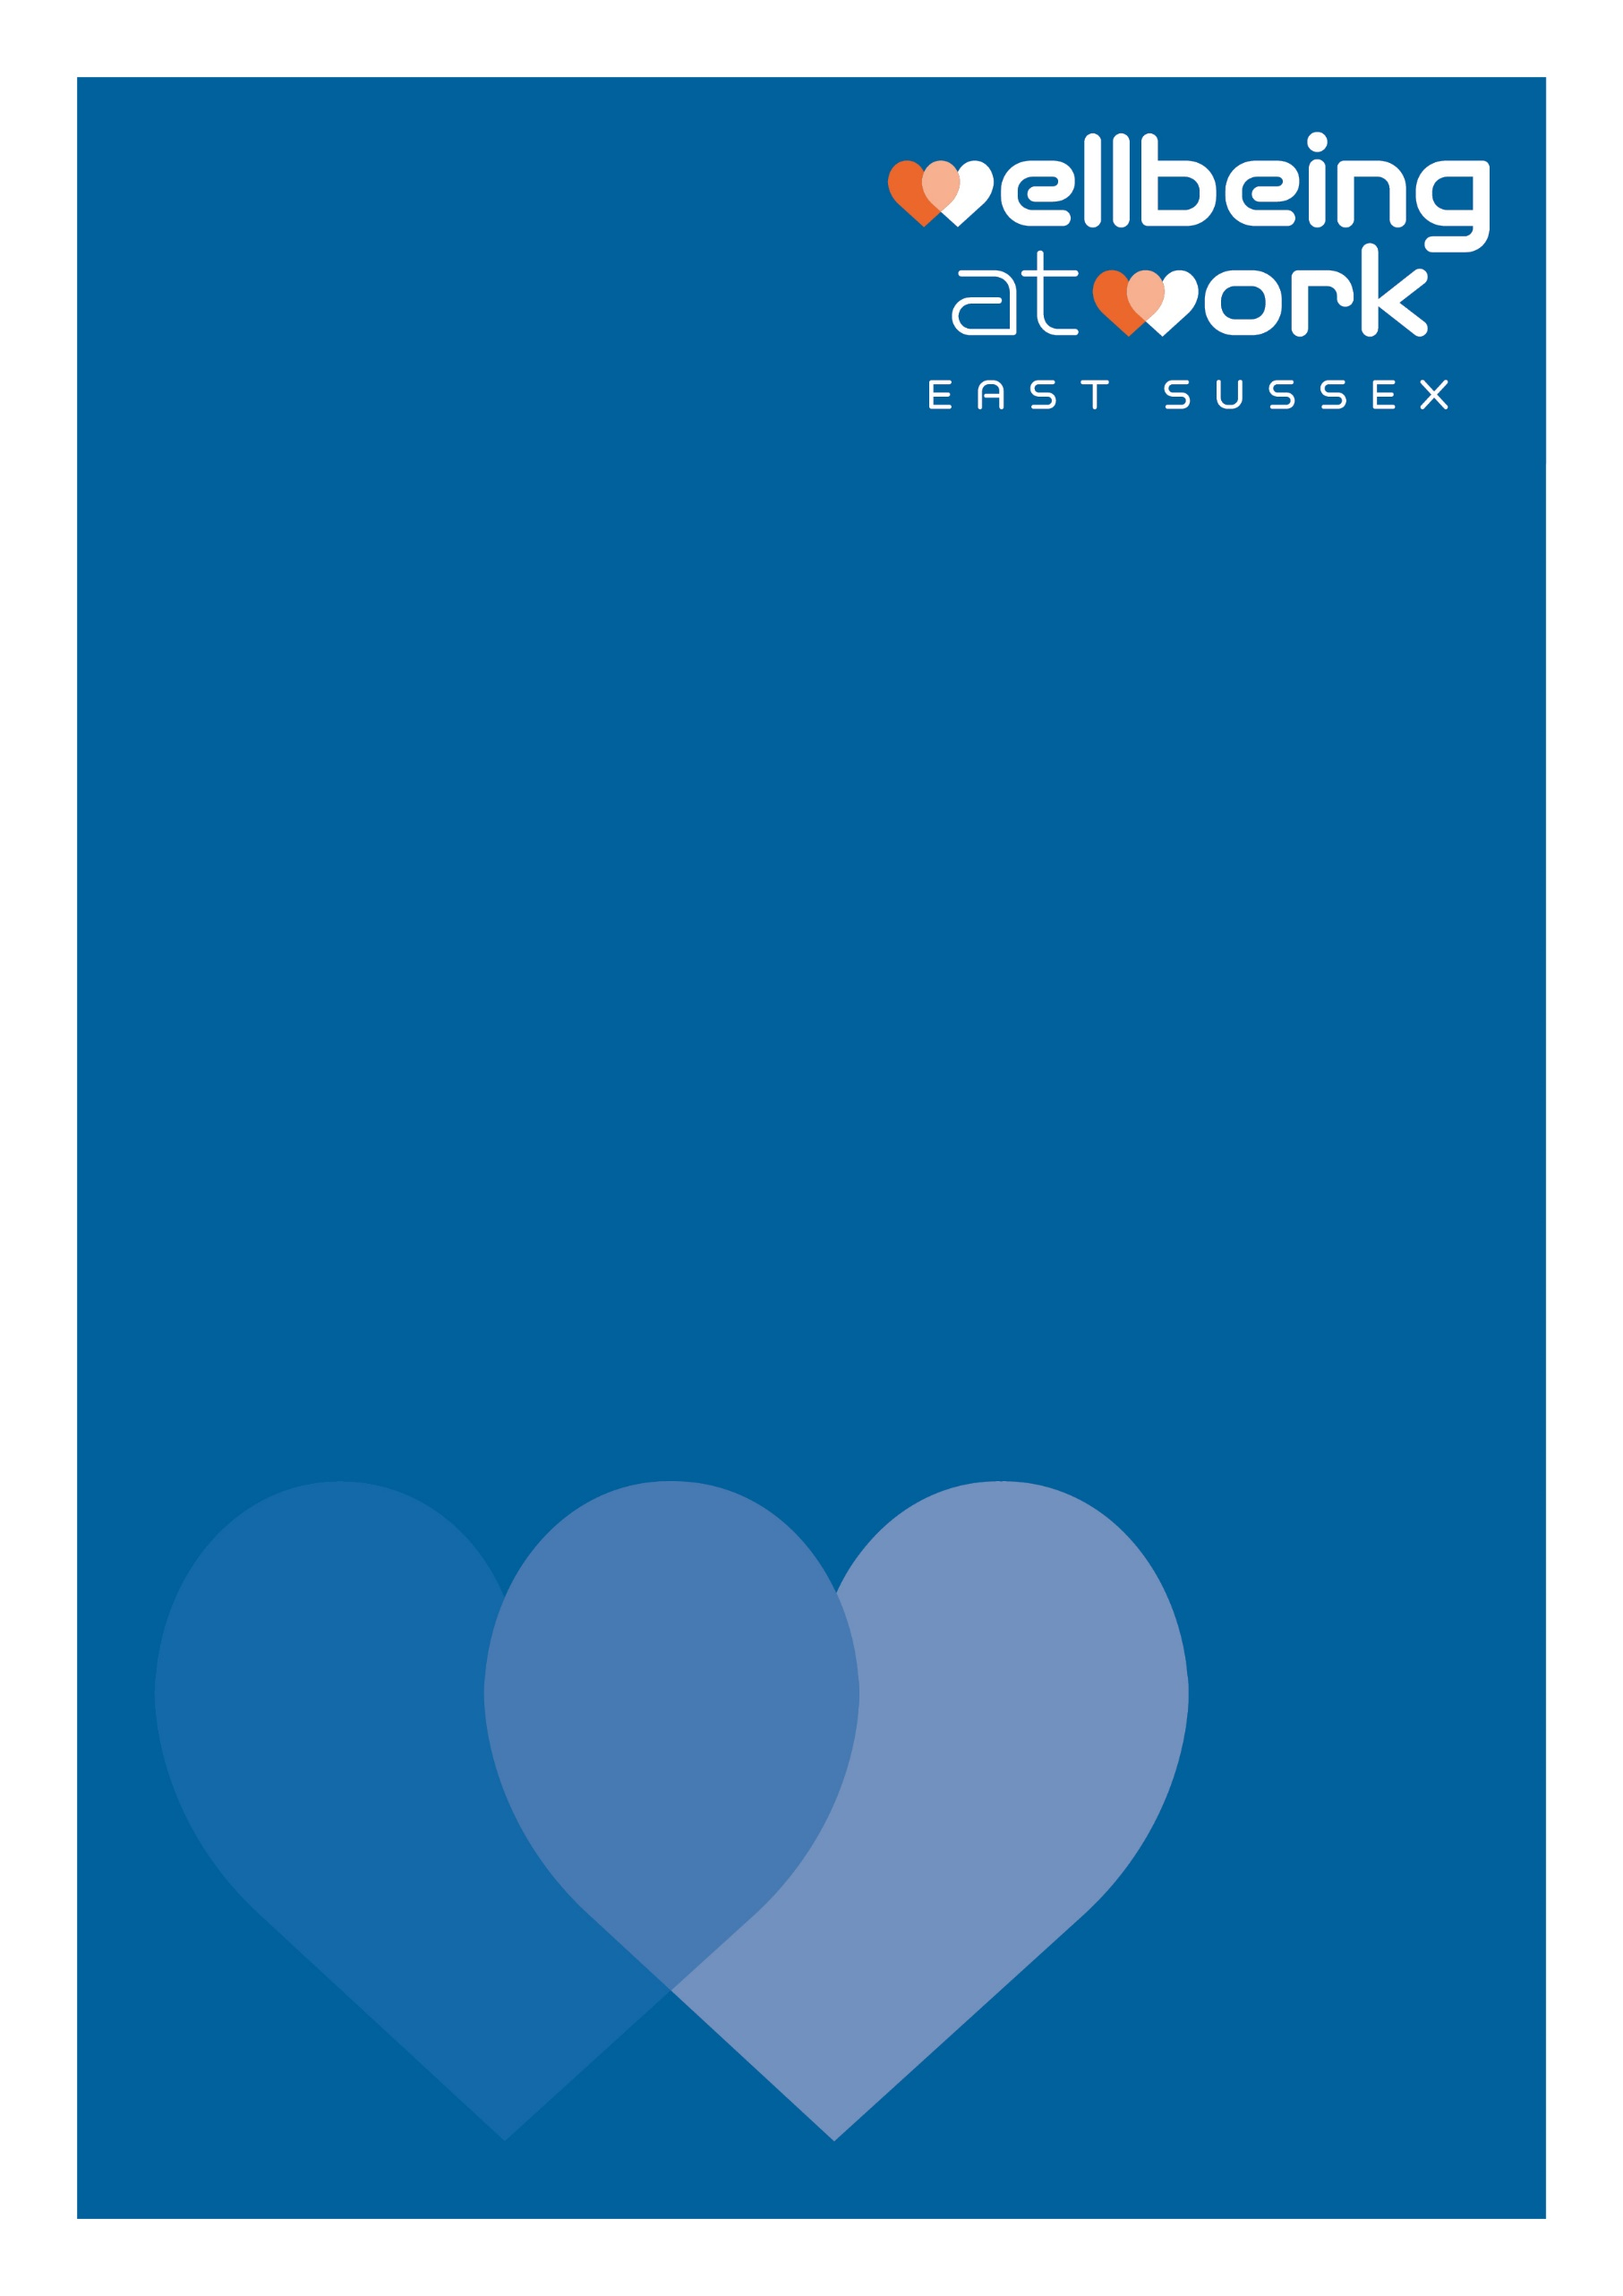
(Organisation Name)
Staff Wellbeing Survey Results Template
Date: (00/00/00)

For more information, contact: healthyworkplace@eastsussex.gov.uk

Further information on how to the assessment works and how to interpret then use the results, can be found here: Workplace health needs assessment (publishing.service.gov.uk)
This Employee Wellbeing Survey has been developed for staff following the Public Health England guidelines, and is available via an online questionnaire produced by the Wellbeing at Work Programme. It is completely confidential and captures the voice of staff.
The main aims of this survey are to:
- Find out about the health & wellbeing issues of importance to all staff
- Gain a better understanding of the type of support staff would like
- Clarify how staff would like to access health information, support and guidance
This summary report presents the key findings whilst keeping individual responses confidential. Please complete the report by filling in the yellow highlighted areas with your organisations survey responses. There is a chart generator excel spreadsheet which works alongside this document, to complete any data analysis and produce charts for you.
A completed copy of this report can be provided as evidence for commitment award, criteria SB.LM.1 (Small Workplace Wellbeing at Work award) and also for LM.B3 (Wellbeing at Work award).

(Name) completed the survey in (Month, Year).
Number of respondents: XX
Respondents as a percentage of workforce: XX %

Contents

Section 1 – General Health and Wellbeing 3
Section 2 - Smoking 6
Section 3 – Healthy Eating 7
Section 4 – Alcohol 8
Section 5 - Physical Activity 9
Section 6 - Sleep 10
Section 7 – Work and Health 11
Section 8 – Workplace Culture 12
Section 9 – Workplace Illness and Injury 14
Section 10 – Supplementary Questions for Line Managers 15

Section 1 – General Health and Wellbeing
The first four health questions are asked annually in the ONS Annual Population Survey – the last dataset we have available is for April 2020 to March 2021.

Q1) How is your health in general?
The majority of respondents (number, XX%) are in XXX (very good/good/fair/bad/very bad) health.
Figure 1: General Health Status
Insert chart from the chart generator Excel spreadsheet.
How does this compare with national and local data?
Figure 2: Comparison of General Health Status with Local and National Data
 | Number of respondents Organisation (year) | % of respondents Organisation (year) | South East (2014, ONS Integrated Household Survey) | England (2014, ONS Integrated Household Survey)
Very good health |  |  | 38.5% | 36.5%
Good health |  |  | 40.1% | 38.9%
Fair health |  |  | 16% | 17.5%
Bad health |  |  | 4.3% | 5.5%
Very bad health |  |  | 1.1% | 1.7%

Q2) Overall, how satisfied are you with your life in general? (On a scale of 0-10, where 0 is not at all satisfied and 10 is completely satisfied)
Number of respondents (xx%) scored themselves 7 or more for being satisfied in life. This compares FAVOURABLY/LESS FAVOURABLY (delete as appropriate) with the national figure of 77% of people rating life satisfaction as 7,8,9,10 as measured in the Annual Population Survey (2020-2021, ONS).
Figure 3: Staff Satisfaction with Life
Insert chart from the chart generator Excel spreadsheet

Figure 4: Comparison of Staff Satisfaction with Life with Local and National Data
Levels of Satisfaction | No. of respondents  Organisation (year) | % of respondents Organisation (year) | East Sussex (ONS Annual population survey April 2020 – March 2021) | UK (ONS Annual population survey April 2020 – March 2021)
Very high (scores of 9-10) |  |  | 27% | 24%
High (scores of 7-8) |  |  | 48% | 53%
Medium (scores of 5-6) |  |  | 20% | 17%
Low (scores of 0-4) |  |  | 5% | 6%

Q3) Overall, how happy did you feel yesterday? (On a scale of 0-10, where 0 is not happy at all and 10 is completely happy)
Number of respondents (xx%) scored themselves a 7 or more for feeling happy yesterday. This compares FAVOURABLY/LESS FAVOURABLY (delete as appropriate) with the national figure of 72% of people rating happiness yesterday as 7,8,9,10 as measured in the Annual Population Survey (2020-2021, ONS).
Figure 5: Staff Happiness Yesterday
Insert chart from the chart generator Excel spreadsheet.
Figure 6: Comparison of Staff Happiness Yesterday with National and Local Data
Staff Happiness | No. of respondents  Organisation (year) | % of respondents Organisation (year) | East Sussex (ONS Annual population survey April 2020 – March 2021³) | UK (ONS Annual population survey April 2020 – March 2021⁴)
Very High Happiness (scores of 9-10) |  |  | 31% | 30%
High Happiness (scores of 7-8) |  |  | 43% | 42%
Medium Happiness (scores of 5-6) |  |  | 17% | 19%
Low Happiness (scores of 0-4) |  |  | 9% | 9%

Q4) Overall, to what extent do you feel the things you do in life are worthwhile? (On a scale of 0-10, where 0 is not at all and 10 is completely worthwhile)
Number of respondents (xx%) scored themselves a 7 or higher for feeling the things they do in life are worthwhile. This compares FAVOURABLY/LESS FAVOURABLY (delete as appropriate) with the national figure of 81% of people rating feeling things they do in life are worthwhile as 7,8,9,10 as measured in the Annual Population Survey (2020-2021, ONS).
Figure 7: Extent that Staff Feel Things in Life are Worthwhile
Insert chart from the chart generator Excel spreadsheet.
Figure 8: Comparison of the Extent that Staff Feel Things in Life are Worthwhile with National and Local Data
 | No. of respondents  Organisation (year) | % of respondents Organisation (year) | East Sussex (ONS Annual population survey April 2020 – March 2021³) | UK (ONS Annual population survey April 2020 – March 2021⁴)
Very High (scores of 9-10) |  |  | 33% | 31%
High (scores of 7-8) |  |  | 47% | 50%
Medium (scores of 5-6) |  |  | 14% | 14%
Low (scores of 0-4) |  |  | 6% | 5%

Q5) Overall, how anxious did you feel yesterday? (On a scale of 0-10, where 0 is not at all anxious and 10 is completely anxious)
Number of respondents (xx%) scored themselves 6 or more for feeling anxious yesterday, however number (xx%) scored themselves 3 or less for feeling anxious. This compares FAVOURABLY/LESS FAVOURABLY (delete as appropriate) with the national figure of 57% of people rating feeling things their anxiety as 0, 1, 2 or 3 as measured in the Annual Population Survey (2020-2021, ONS).
Figure 9: Staff Anxiety Yesterday
Insert chart from the chart generator Excel spreadsheet.

Figure 10: Comparison of Staff Anxiety Yesterday with National and Local Data
 | No. respondents  Organisation (year) | % of respondents Organisation (year) | East Sussex (ONS Annual population survey April 2020 – March 2021³) | UK (ONS Annual population survey April 2020 – March 2021⁴)
Very Low Anxiety (scores of 0-1) |  |  | 33% | 33%
Low Anxiety (scores of 2-3) |  |  | 20% | 24%
High Anxiety (scores of 4-5) |  |  | 20% | 19%
Very High Anxiety (scores 6-10) |  |  | 27% | 24%

Section 2 – Smoking
Q6) Which best describes you?
Number of respondents (xx%) stated that they smoke daily or that they smoke occasionally but not every day. This compares FAVOURABLY/LESS FAVOURABLY (delete as appropriate) with 13.9% of adults aged 18+ in England currently smoke (Public Health England, 2019) and 12.6% of adults aged 18+ currently smoke in East Sussex (Public Health England, 2019).
Smoking rates are typically higher in adults that are in routine and manual occupations (aged 18-64). In East Sussex, 27.9% of adults in routine and manual occupations (aged 18-64) smoke, compared to 23.7% in England (Public Health England, 2019).
Figure 11: Staff Smoking Frequency
Insert chart from the chart generator Excel spreadsheet.

Q7) If you smoke, would you like support to quit? And if so, what kind of support would you find most helpful for quitting?
When the smokers were asked what support, if any, they would find most helpful for quitting smoking they responded with the below (some smokers selected more than one option from the list):

Figure 12: Smoking - Preferred Support for Quitting
Insert chart from the chart generator Excel spreadsheet.
Insert a paragraph with any explanations to findings. Add in the table below any answers for ‘Other’.
Theme of Comment | No. of Respondents

Section 3: Healthy Eating
Q8) How many portions of fruit and/or vegetables, of any sort, do you eat on a typical day?
The recommendation for adults (PHE, 2014) is to eat five portions or more of fruit and vegetables every day.
Number of respondents (xx%) said they eat five or more portions of fruit and vegetables a day. This compares FAVOURABLY/LESS FAVOURABLY (delete as appropriate) with local data which indicated that 61% of adults met the five-a-day recommendation in East Sussex, and 58.3% in England (Public Health England, 2019/20).
Figure 13: Staff Fruit and Veggie Consumption
Insert chart from the chart generator Excel spreadsheet.

Q9) Would you like help with your diet or weight? And if so, what kind of support would you find most helpful?
Figure 14: Healthy Eating - Preferred Support
Insert chart from the chart generator Excel spreadsheet.
Insert a paragraph with any explanations to findings. Add in the table below any answers for ‘Other’.
Theme of Comment | No. of Respondents

Section 4: Alcohol
Q10) How often do you have a drink containing alcohol?
Number of respondents (xx%) drink alcohol more than once a week.
Figure 15: Frequency of Drinking Alcohol
Insert chart from the chart generator Excel spreadsheet.

Q11) How many units of alcohol do you drink, on a typical day when you drink alcohol?
Figure 16: Quantity of Alcohol Drunk on a Typical Drinking Day
Insert chart from the chart generator Excel spreadsheet.

Q12) How often have you had six or more units if female, or eight or more units if male, on a single occasion in the last year?
The definition used by the Office of National Statistics for binge drinking is having over 8 units in a single occasion for men and over 6 units per women. Number of respondents (xx%) binge drink at least once a month.
Figure 17: Frequency of Staff Binge Drinking in the Past Year
Insert chart from the chart generator Excel spreadsheet.

Q13) Would you like help with reducing your alcohol consumption? And if so, what kind of support would you find most helpful?
Figure 18: Alcohol - Preferred Support
Insert chart from the chart generator Excel spreadsheet.
Insert a paragraph with any explanations to findings. Add in the table below any answers for ‘Other’.
Theme of Comment | No. of Respondents

Section 5: Physical Activity
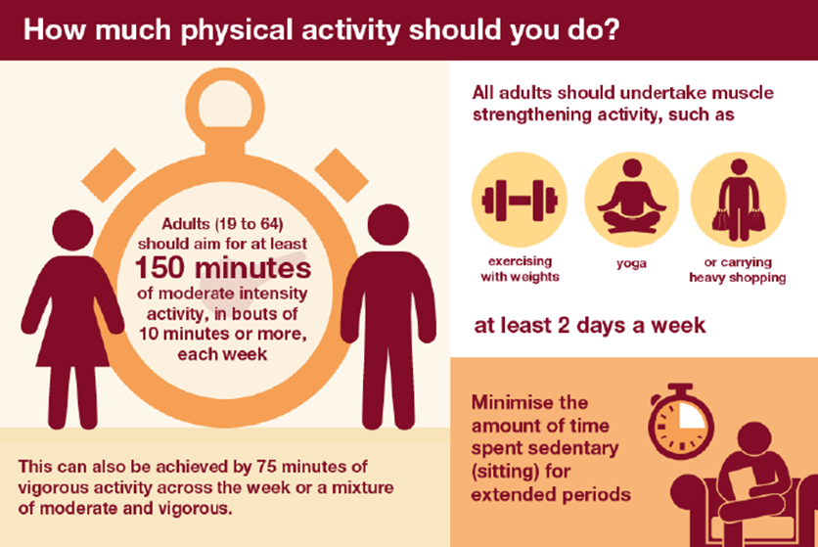
Q14) In the past week, on how many of the days have you done a total of 30minutes or more of physical activity, which was hard enough to make you breathe harder?
150 minutes physical activity a week would equate to five days of 30 minutes (crude estimate assuming exercise performed regularly through the week). Number of respondents (xx%) do the recommended weekly amount of aerobic physical activity. This compares FAVOURABLY/LESS FAVOURABLY (delete as appropriate) with local data as currently 69.4% of adults in East Sussex are physically active, and the figure is 66.4% of adults are physically active in England (Public Health England 2019/20).
Figure 19: Number of Days Staff Done 30 mins of Aerobic Activity
Insert chart from the chart generator Excel spreadsheet.

Q15) Would you help with physical activity? And if so, what kind of support would you find most helpful?
Figure 20: Physical Activity - Preferred Support
Insert chart from the chart generator Excel spreadsheet.
Insert a paragraph with any explanations to findings. Add in the table below any answers for ‘Other’.
Theme of Comment | No. of Respondents

Section 6: Sleep
Q16) Over the last month, to what extent has your sleep troubled you in general?
Number of respondents (xx%) have had a varying degree of sleep problems in the last month, with only number (xx%) saying sleep had not troubled them at all. Almost half of British people say that stress or worry keeps them awake at night (PHE, Workplace Health Needs Assessment Guidelines). According to The Sleep Charity, 40% of adults and children suffer with sleep issues and sleep deprivation costs the economy £40.2 billion in lost productivity.
Figure 21: Extent Sleep Has Troubled Staff
Insert chart from the chart generator Excel spreadsheet.

Q17) Would you like help with improving your sleep? And if so, what kind of support would you find most helpful?
Figure 22: Sleep - Preferred Support
Insert chart from the chart generator Excel spreadsheet.
Insert a paragraph with any explanations to findings. Add in the table below any answers for ‘Other’.
Theme of Comment | No. of Respondents

Section 7: Work and Health
Q18) In general, how satisfied are you with:
When asked, number of respondents (xx%) said that they are very satisfied or quite satisfied with their job, number (xx%) are very satisfied or quite satisfied with the social environment at work, and number (xx%) are very satisfied or quite satisfied with the physical environment at work.

Number of respondents (xx%) stated that they are quite dissatisfied or very dissatisfied with their job. Number (xx%) are quite dissatisfied or very dissatisfied with the social environment at work, and number (xx%) are quite dissatisfied or very dissatisfied with the physical environment at work.

Figure 23: Level of Staff Satisfaction with Job and Environment at Work
Insert chart from the chart generator Excel spreadsheet.

Q19) In general, how do you find your job?
When asked, number of respondents (xx%) reported that they found their job very stressful or extremely stressful, with number (xx%) reporting finding their job mildly or not at all stressful.
Figure 24: Stress at Work
Insert chart from the chart generator Excel spreadsheet.

Section 8: Workplace Culture
Q20) Considering the working conditions in your workplace in the last three months, please indicate how true the following statements are for you:
Figure 25: Working Conditions in the Last 3 months
Insert chart from the chart generator Excel spreadsheet.
Add data from the chart generator Excel spreadsheet in the table below (or you can just insert the table from the Excel spreadsheet).

 | Strongly agree |  | Agree |  | Neither |  | Disagree |  | Strongly disagree |  | Blank
 | No. | % | No. | % | No. | % | No. | % | No. | % | No.
We can use personal initiative or judgement

We can adapt my job roles accordingly to the workplace needs

Negative feedback is provided in a constructive way

We feel listened to
The management show that they have confidence in the people who work for them
There are opportunities to develop friendships
There is good cooperation between colleagues
There is support for us if we need to provide informal care for a family member

Communication is good
We can have 1 to 1 meetings with our manager
In our own work, it is possible to learn new things and skills

My employer supports my health and wellbeing

Q21) Do you feel able to speak to your manager about stress, anxiety, depression, or any other mental health concerns?
Figure 26: Ability to Talk to Manager about Mental Health
Insert chart from the chart generator Excel spreadsheet.

Q22) Would you like support for your mental health? And if so, what kind of support would you find most helpful?
Figure 27: Mental Health - Preferred Support
Insert chart from the chart generator Excel spreadsheet.
Insert a paragraph with any explanations to findings. Add in the table below any answers for ‘Other’.
Theme of Comment | No. of Respondents

Q23) If there was one thing in your workplace that would improve your health and well-being , what would it be?
Insert a paragraph with any explanations to findings. Add in the table below a summary of the answers.
Theme of Comment | No. of Respondents

Section 9: Workplace Illness and Injury:
Q24) In the last 12 months, have you suffered from an injury or illness that was either caused or made worse by your current job?
Figure 28: Workplace Injury or Illness
Insert chart from the chart generator Excel spreadsheet.
Add in the table below any answers for ‘Other’.
Theme of Comment | No. of Respondents

Q25) In the last 12 months, have you gone to work despite feeling that you should have taken the day off sick?
Figure 29: N. of times staff have gone to work despite feeling unwell (in percentage)
Insert chart from the chart generator Excel spreadsheet.

Q26) Would you like advice or support for aches and pains? (such as back ache, neck pain etc) And if so, what would you find most helpful?
Figure 30: Aches and Pains – Preferred Support
Insert chart from the chart generator Excel spreadsheet.
Add in the table below any answers for ‘Other’.
Theme of Comment | No. of Respondents

Section 10: Supplementary questions for line managers:
Q27) How confident are you in discussing and/or providing support and advice on any of the following, to those that you directly line manage?
Figure 31: Managers’ Level of Confidence in Talking to Staff
Insert chart from the chart generator Excel spreadsheet.
Add data from the chart generator Excel spreadsheet in the table below (or you can just insert the table from the Excel spreadsheet).

 | Very confident |  | Quite confident |  | Neither confident or unconfident |  | Not so confident |  | Not confident at all |  | Blank
 | No. | % | No. | % | No. | % | No. | % | No. | % | No.
Sickness absence

Return to work interviews

Workplace adjustments

Having difficult conversations
Bullying and harassment
Healthy eating
Mental health and stress
Stopping smoking

Alcohol consumption
Sleep

Q28) What barriers prevent you from being able to promote and encourage good health and wellbeing practices to those you directly manage? E.g. being active, eating healthily, not smoking etc
Figure 32: Barriers to Health and Wellbeing Promotion
Insert chart from the chart generator Excel spreadsheet.

Integrated Household Survey, Jan to Dec 2014, ONS
Annual personal wellbeing estimates April 2020 to March 2021, Local Authority update edition, ONS
Annual personal wellbeing estimates April 2020 to March 2021, UK and Countries edition, ONS
https://www.nhs.uk/news/food-and-diet/call-to-make-5-a-day-fruit-and-veg-into-7-a-day/

