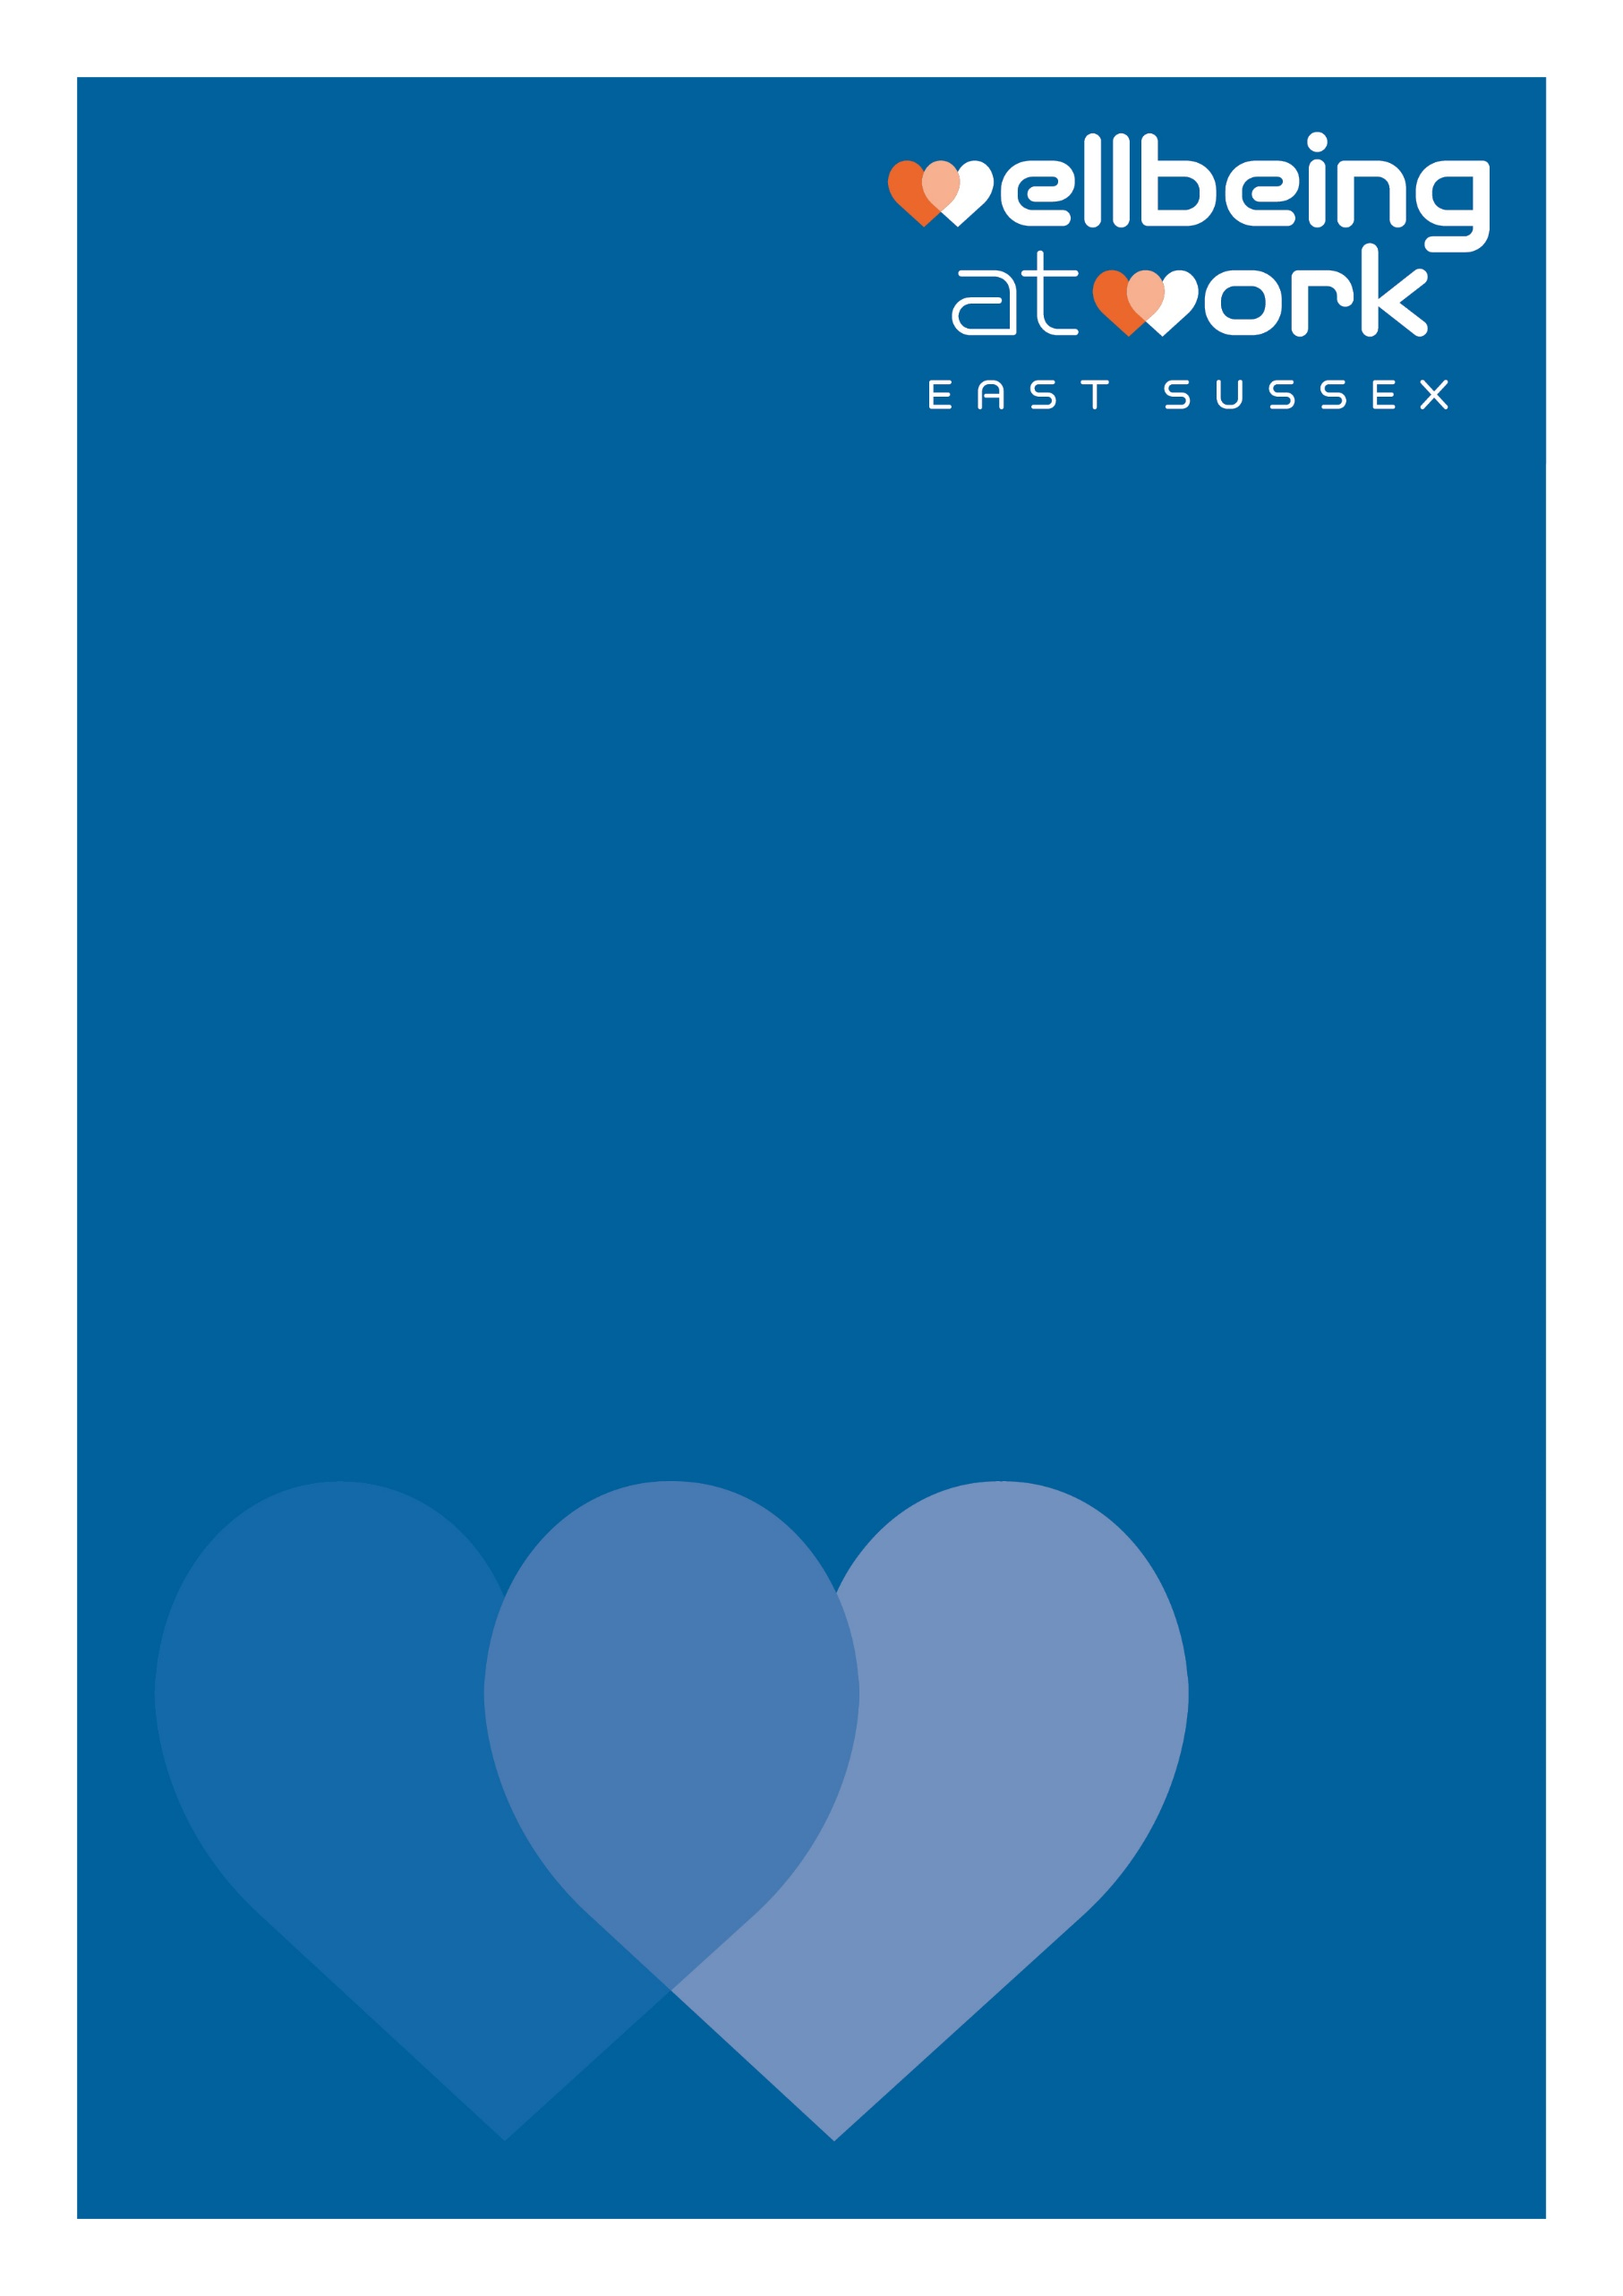
(Organisation Name)
Staff Wellbeing Survey Results Template – short summary
Date: (00/00/00)

For more information, contact: healthyworkplace@eastsussex.gov.uk

Introduction on how to use this document:
This summary report presents the key findings whilst keeping individual responses confidential. You can produce this report by choosing to display either:
- Only the three strongest and the three weakest points across the whole survey (the three highest and the three lowest stats) – see appendix 1 below; OR

- A brief summary of each of the nine sections of the survey - see appendix 2 below

There is a chart generator excel spreadsheet which can work alongside this document, to complete any data analysis and produce any charts you may wish to include. Or you can use the data analysis provided by MS Forms in the ‘Responses’ tab (see image below).
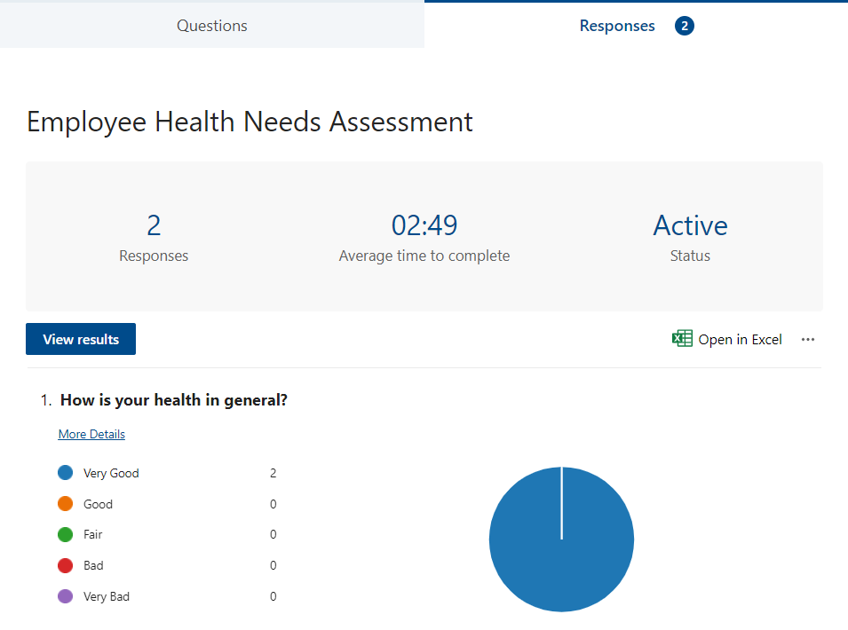

A completed copy of this report can be provided as evidence for Commitment Award, Criteria SB.LM.1 for the Small Business Wellbeing at Work Awards, or Criteria LM.B3 for the Wellbeing at Work Awards.

Appendix 1: Template for a brief survey summary report
Number of respondents: XX
Respondents as a percentage of workforce: XX %
Here is a summary of the Staff Health Needs Assessment Survey and what is being put in place moving forward to support our employees’ wellbeing.
General Wellbeing
The majority of staff (Xx%) feel their health in general is xx (very good/good/fair/bad/very bad – change accordingly). When asked how satisfied they are with their life in general, xx% of staff scored themselves 7 or more on a scale of 1-10. In the UK, 77% of people rated life satisfaction as 7,8,9,10 in the Annual Population Survey (2020-2021, ONS).
Smoking
xx% of staff stated that they smoke daily or that they smoke occasionally but not every day (or xx% of staff said they don’t smoke or smoke only occasionally - describe the smoking habits of the majority). For reference, 12.6% of adults aged 18+ currently smoke in East Sussex (Public Health England, 2019). When asked what kind of support they would like to quit, the majority said xx
(Example that could be used throughout the report: 50% of staff smoke but only 3 employees would like support with quitting, and their preferred kind of support is signposting to resources and advice from a GP. Or the majority of staff wouldn’t like any support with quitting).
Eating
xx% of staff eat five or more portions of fruit and vegetables a day. For reference, 61% of adults met the five-a-day recommendation in East Sussex (Public Health England, 2019/20). Xx% would like support with weight loss, and their preferred kind of support is xxx.
Drinking
xx% of employees drink alcohol more than once a week. When they drink, staff usually drink xx units of alcohol. For reference, the definition used by the Office of National Statistics for binge drinking is having over 8 units in a single occasion for men and over 6 units for women. xx employees would like support with reducing alcohol intake, and their preferred kind of support is xxx.
Physical Activity
xx% of staff do the recommended amount of 30 minutes a day or more of aerobic physical activity. For reference, 69.4% of adults in East Sussex are physically active (Public Health England 2019/20). xx employees would like support with getting more active, and their preferred kind of support is xxx.
Sleep
Xx% of staff have had a varying degree of sleep problems in the last month, with only number employees (xx%) saying sleep had not troubled them at all. Their preferred kind of support is xxx.
Work and Health, and Stress at Work
xx% of staff said that they are very satisfied or quite satisfied with their job, xx% are very satisfied or quite satisfied with the social environment at work, and xx% are very satisfied or quite satisfied with the physical environment at work. (Also add any stand out numbers for quite dissatisfied or very dissatisfied with the job, the social environment at work or/and the physical environment at work, if there are any).

xx% of staff reported that they found their job very stressful or extremely stressful, with xx% reporting finding their job mildly or not at all stressful.
Workplace Culture, and Mental Health
When asked about the working conditions, our staff agreed or strongly agreed that these areas are working well – list areas e.g. opportunities to develop friendships, cooperation between colleagues, etc; and these areas need improvement or could be better – list areas e.g. communication, 1-1 with line managers, etc.
% feel able to speak to their manager about stress, anxiety, depression, or any other mental health concerns. In terms of preferred mental health support, the majority listed xxx.
Workplace Illness and Injury
% said that, in the last 12 months, they have suffered from an injury or illness that was caused or made worse by work. % said that they have you gone to work despite feeling that they should have taken the day off sick. In terms of preferred support for aches and pains (back ache, neck pain etc), the majority listed xxx.
Action:
Given those results, we will focus our wellbeing initiatives on xxx. This is what we are going to do: xxx.
If you have questions about the survey results, or would like further support or advice, please speak to xxx (add the contact details of someone in the business able to help; this could be the wellbeing lead, HR or a wellbeing champion).

Appendix 2: Template for a 1-page survey summary report
Thank you to everyone who participated in our employee wellbeing survey. Here is the summary of the results, and what we are going to do moving forward to better support your health and wellbeing in the workplace:
The survey ran from xx to xx. We had xx responses, which is xx% of our workforce.
80% of respondents feel their health is good or very good.
67% of respondents don’t drink or drink less than once a month.
Although 50% of respondents smoke, only three employees would like support with quitting. 87% of respondents wouldn’t like any support with weight loss.
Sleeping problems is a concern for 80% of respondents and 22% would like support with their sleeping habits, or how to sleep longer and better.
Given these results, we will be focusing our wellbeing initiatives in the next three months on supporting our staff sleep hygiene. We will be sharing hints and tips on how to improve your quality of sleep. If you have any questions about the survey results, or would like specific support or advice, please speak to HR.

