East Sussex Wellbeing at Work
Welcome Pack

Welcome!
Thank you for registering for the East Sussex Wellbeing at Work Accreditation Programme. It’s great to have you on board!
This user handbook provides a step-by-step guide of how to become a Wellbeing at Work Accredited Employer.

The Programme
The East Sussex Wellbeing at Work (ESWAW) Award recognises your commitment, as a local employer, to supporting employee wellbeing through an accreditation programme. The programme is the county standard of good practice in health and wellbeing, operated by Public Health at East Sussex County Council, and provides a framework for improving health and wellbeing in the workplace.
The programme will guide you on a journey of health improvement through a series of awards, which contain specific criteria to achieve across a range of topic areas:
- Physical Activity and Active Travel;
- Healthy Eating;
- Musculoskeletal Health and Health & Safety;
- Mental Health;
- Sickness Absence, Return to Work and Prevention;
- Alcohol, Substance Misuse and Stop Smoking;
- Leadership, Management and Workplace Culture.

Available Awards
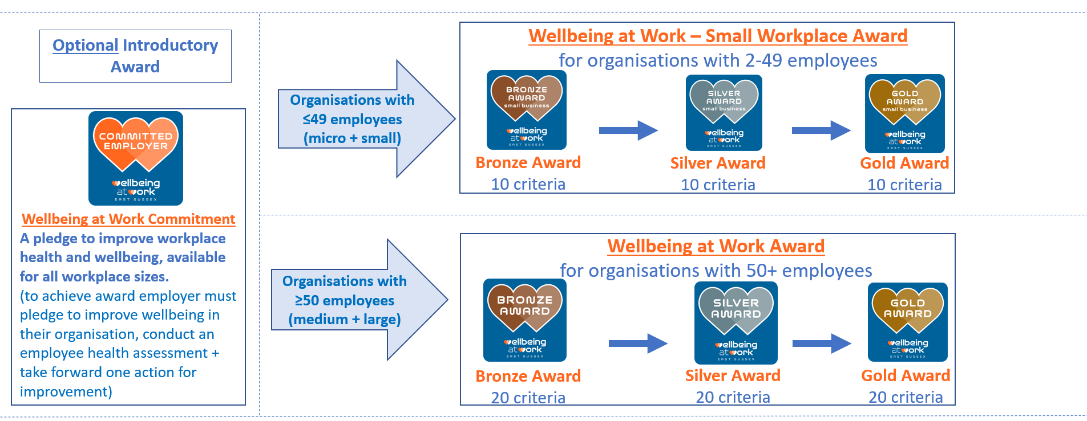

For Small Workplaces (2-49 employees):
If you are a small, or micro, organisation (a workplace with 2 to 49 employees), the following awards are available to you:
- Commitment Award (optional): This is a great place for you to start if you are thinking about undertaking a wellbeing improvement journey for the first time. To achieve this award, all you need to do is run an employee health needs assessment survey and highlight one action to take forward from the results.
- Small Business Bronze Award: to achieve Bronze, 10 criteria must be achieved with 5 already defined and 5 of your choice from a pool of criteria. This award is focused on promoting and encouraging positive health behaviours through providing information, starting the conversation and signposting to support services available. At this level, you would have built the foundations for a healthy workplace with minimal financial investment.
- Small Business Silver Award: to achieve Silver, Bronze Award must have already been completed. A further 10 criteria must be achieved with 5 already defined and 5 of your choice from a pool of criteria. This award is focused on enabling positive health behaviours and wellbeing, by starting to take action and bringing about organisational change. At this level, you would have developed health and wellbeing in your workplace.
- Small Business Gold Award: to achieve Gold, Silver Award must have already been completed. And a further 10 criteria must be achieved with 5 already defined and 5 of your choice from a pool of criteria. This award is focused on fostering positive health behaviours, and positive workplace culture is part of the organisation’s values. At this level, health and wellbeing is embedded in your organisation.

You can find the full list of criteria for the Small Business Bronze, Silver and Gold Awards on our website here: Small Business Awards Criteria - East Sussex Wellbeing At Work
For ideas, useful resources and examples of evidence you may want to provide, please refer to the Criteria Handbooks, available on our website here: Accreditation Supporting Documents - East Sussex Wellbeing At Work

For Larger Workplaces (50+ employees):
If you are a medium, or large, organisation (a workplace more than 50 employees), the following awards are available to you:
- Commitment Award (optional): This is a great place for you to start if you are thinking about undertaking a wellbeing improvement journey for the first time. To achieve this award, all you need to do is run an employee health needs assessment survey and highlight one action to take forward from the results.
- Bronze Award: to achieve Bronze, 20 criteria must be achieved, all of which are mandatory and defined. At this level, you will build the foundations for a healthy workplace with minimal financial investment.
- Silver Award: to achieve Silver, Bronze Award must have already been completed. And a further 20 criteria must be achieved, these criteria can be chosen by the organisation from a pool of optional criteria. At this level, you would have developed health and wellbeing in your workplace.
- Gold Award: to achieve Gold, Silver Award must have already been completed. And a further 20 criteria must be achieved, these criteria can be chosen by the organisation from a pool of optional criteria. At this level, health and wellbeing is embedded in your organisation.

You can find the full list of criteria for the Wellbeing at Work Bronze, Silver and Gold Awards on our website here: Wellbeing at Work Awards Criteria - East Sussex Wellbeing At Work
For ideas, useful resources and examples of evidence you may want to provide, please refer to the Criteria Handbooks, available on our website here: Accreditation Supporting Documents - East Sussex Wellbeing At Work

How It Works
- Sign up to ESWAW websites online portal and receive log in details via email.
- Receive email from the ESWAW team including this Welcome Pack.
- Book initial call with the ESWAW team – At this first call, we will:
  - Answer any questions you may have
  - Explore your organisations wellbeing experience so we can best support you on your journey
  - Discuss your timelines – do you have any goals you are working towards?
  - Agree our expectations
  - Discuss Workplace Wellbeing Champion training and booking
- Decide whether to begin your journey at Commitment Award or Bronze Award.
- Begin to work on achieving award criteria, at your own pace.
- Book your 8-week check-in call with the ESWAW team – at this call you can bring along any questions or criteria you have completed, or are in the process of completing. The ESWAW team will be able to assess these criteria and provide guidance or feedback to support your journey towards award status.
- Continue to build your award portfolio.
- Access 12-weekly check-in calls until you are ready to submit your award application via the online portal – just as at the 8 week check in call, you can bring along any questions or criteria you have completed, or are in the process of completing. The ESWAW team will be able to assess these criteria and provide guidance or feedback to support your journey towards award status.
If you haven’t received your login details after signing up to our website, any problems you may have operating the online portal or questions in between the check-in calls, you can drop us an email at healthy.workplace@eastsussex.gov.uk

Assessment Process
- Submit your award application on the online portal, once you feel you have completed all of the award criteria and uploaded evidence for each one. (the ‘Submit’ button will only be active once you have uploaded once piece of evidence against each criteria required for the award level)
- Once your portfolio has been submitted, you won’t be able to change any evidence until the ESWAW team review it.
- The ESWAW team will review your portfolio.
- Once your portfolio has been approved, the ESWAW team will request to book a site visit to your workplace to confirm you meet the criteria and for you to showcase all the brilliant things you have been doing as an organisation! The team will want to meet and speak with representatives across different levels of your organisation.
- Confirmation of your award will be sent and you will be invited to the Annual Wellbeing at Work Award Presentation Event.

Time Scales
There is no set time scale for an organisation to complete an award; the accreditation is flexible to your organisation’s needs. We appreciate that all workplaces will have different goals and varying capacity to support their journey towards the Wellbeing at Work Accreditation, so the programme allows you to complete it as slowly (or speedily!) as is suitable to your organisation.
We simply ask that you stay in contact with us regarding your progress and estimated time scales, so that we can best support you with your accreditation journey providing guidance where needed.

Uploading Evidence to the Online Portal
If you haven’t already, you can register here to our Wellbeing at Work website, where you can manage your application toward award status.

Dashboard
On your dashboard, evidence for each award criteria can be uploaded digitally on the Evidence Folder. You will be able to build your portfolio of evidence at your own pace, track the status of completed criteria and submit your application to be assessed once you are happy that your portfolio is complete. You will also be able to track your award status. This is the dashboard, once you are logged in:
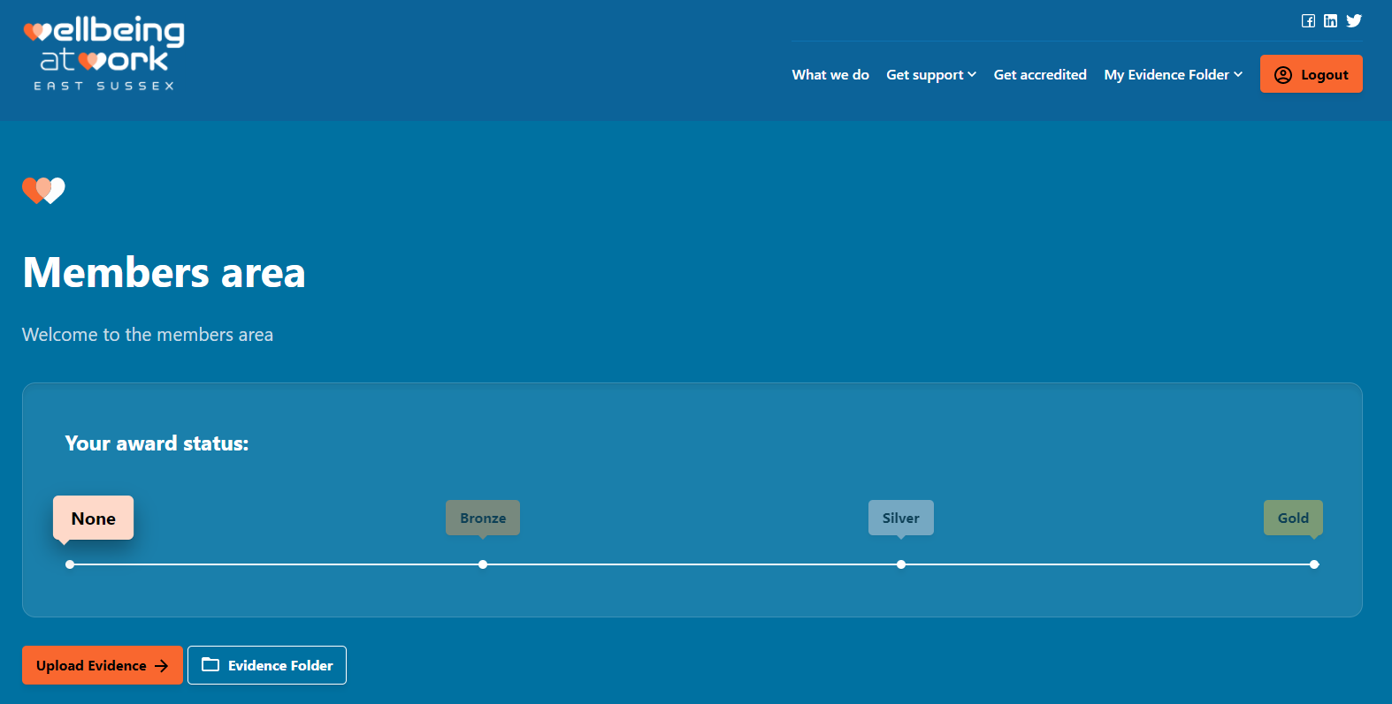

Evidence Folder
You will also have an Evidence Folder, where you will be able to upload evidence against each criteria completed in your awards application. Please note that the website only takes one file (Word, PDF, JPEG or PNG) against each criteria. If you’d like to submit two pieces of information as evidence, e.g. copy of a policy and screenshot of the intranet page where it can be accessed, please save both in the same file before uploading.
The ESWAW team will be able to remotely assess your evidence, providing feedback and guidance where needed. You will also be able to track the assessment status (either pending, approved or rejected), and edit or delete uploaded evidence. This is your Evidence Folder:
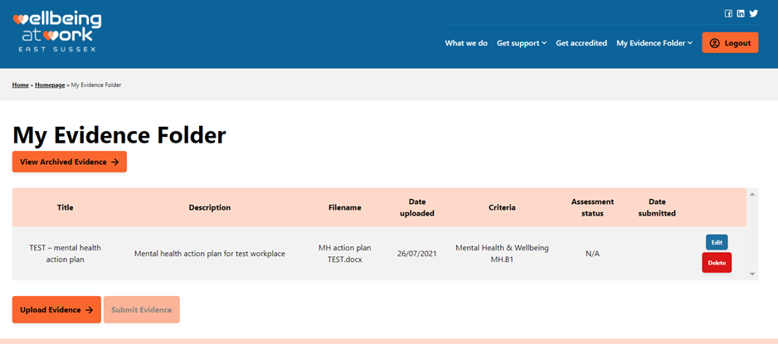

Workplace Health Assessment
Undertaking workplace health assessments, or employee surveys, within your organisation is an important task to ensure that your employees voices are heard, to understand more about your workforce, but it also helps you to measure the impact of any health and wellbeing improvements you are making. That’s why the workplace health survey or assessment is a mandatory criteria at each award level of the Accreditation programme.
According to best practice, an anonymous employee survey or questionnaire should be conducted annually, and you should analyse the results to understand where to target further improvements to health and wellbeing.
We have pulled together a template workplace health assessment for your organisation to use, there is also guidance on using the template and assessing the results. We will send you this template after your initial welcome call.

Workplace Wellbeing Champion Training
As part of the East Sussex Wellbeing at Work Programme, we provide free Workplace Health Champions Training. We encourage you to send at least one employee on this crucial training, delivered over two half-day sessions, as having a workplace health champion in your organisation can help to drive forward your accreditation journey, and wellbeing improvements.
Wellbeing Champions promote healthy lifestyles by inspiring others to take a more active role in their health. Having Workplace Health Champions in place is a great way of ensuring that your entire organisation has access to support and that there are regular activities in place to encourage people to connect with each other.
The course equips champions to:
- Run health campaigns and activities in your workplace
- Initiate and sustain health related conversations with their colleagues
- Gain awareness of local services and resources that colleagues can be signposted towards for support
Champions will gain access to a bi-monthly networking meeting hosted by the Wellbeing at Work team, where champions can access support; best practice examples can be shared; health campaign materials will be distributed and expert-led, topic-based upskill sessions led.
It is expected that an employee being sent on champion training will already have an interest or passion for health and wellbeing, but they don’t need any prior knowledge or training in the area. It is helpful to get your future champions booked onto a course as soon as your start the accreditation journey, as they will be able to support your wellbeing initiatives.
You can find out more about the training, and access the booking forms, on the website.
If you have any queries about the process or the accreditation itself, please get in touch with the team at HealthyWorkplace@eastsussex.gov.uk

